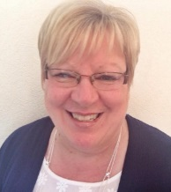 | Cllr Mandy Cartwright  Tel: 07812 486670  Email: cartright208@btinternet.com  Ward: Ketley  Group: Labour  Member: Resources Committee | 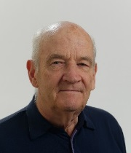 | Cllr David Elliott  Tel: 01952 252459  Email: david.elliott41@talktalk.net  Ward: Ketley  Group: Independent  Chairman: Resources Committee | 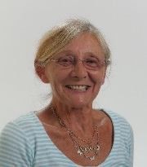 | Cllr Maggie Evans  Tel: 01952 617029  Email: evansmaggot@blueyonder.co.uk  Ward: Ketley  Group: Independent  Chairman: Finance Committee
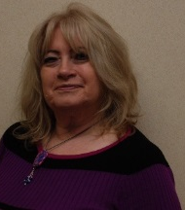 | Cllr Joy Francis  Tel: 01952 613750  Email: joyfrancis2@aol.com  Ward: Ketley  Group: Conservative  Member: Finance Committee | 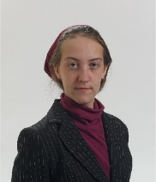 | Cllr Laura Hodgkinson  Tel: 07597 783  Email: darksparkles@hotmail.co.uk  Ward: Ketley  Group: Independent  Member: Resources Committee  Member: Finance Committee | 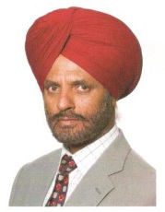 | Cllr Amrik Singh Jhawar  Tel: 01952 252530  Email: a.jhawar@sky.com  Ward: Ketley  Group: Labour  Chairman: Ketley Parish Council  Member: Finance Committee
 | Cllr Rajash Mehta  Tel: 07545 023519  Email: dr.saab@nhs.net  Ward: Beverley  Group: Labour (co-opted)  Member: Resources Committee |  | Cllr Samuel Millward-Thomas  Tel: 07909 578127  Email: samuelthomas@mail.com  Ward: Beverley  Group: Independent (co-opted)  Member: Resources Committee | 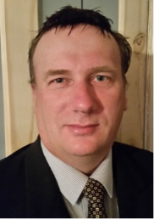 | Cllr Andy Morris  Tel: 07952 934526  Email: themorris@blueyonder.co.uk  Ward: Ketley  Group: UK Independence Party
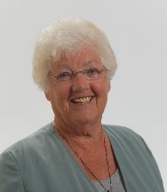 | Cllr Hilda Rhodes  Tel: 01952 249156  Email: hilda.rhodes@telford.gov.uk  Ward: Ketley  Group: Labour  Vice Chairman:Ketley Parish Council | 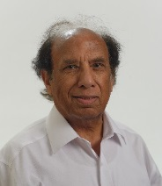 | Cllr Anil Saini  Tel: 01952 618848  Email: sainitelford@hotmail.com  Ward: Ketley  Group: Labour  Member: Finance Committee |  | 23/06/17

